**Steps followed while creating the Web service application**

1. Open Android Studio and create a new project from file menu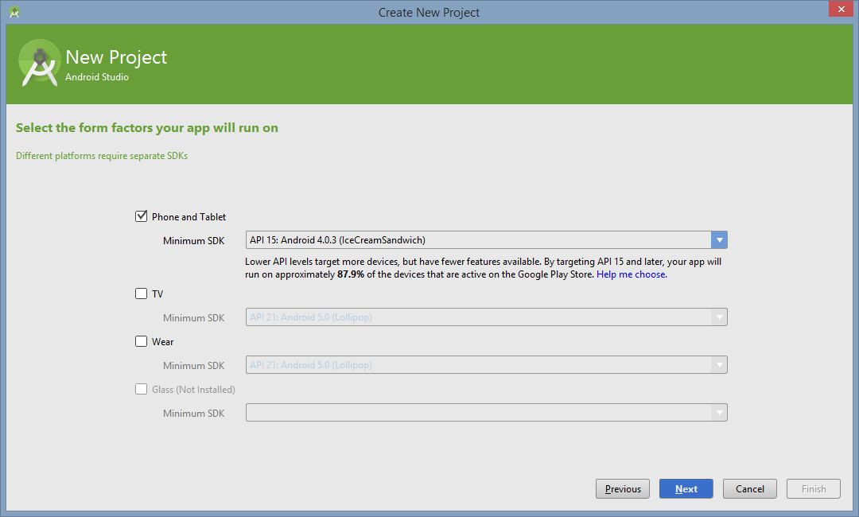

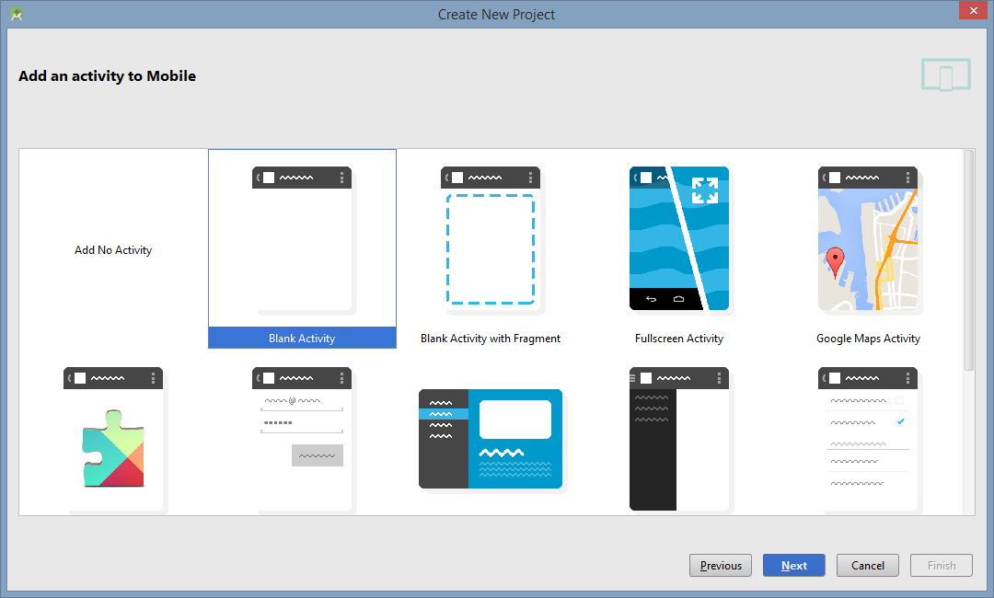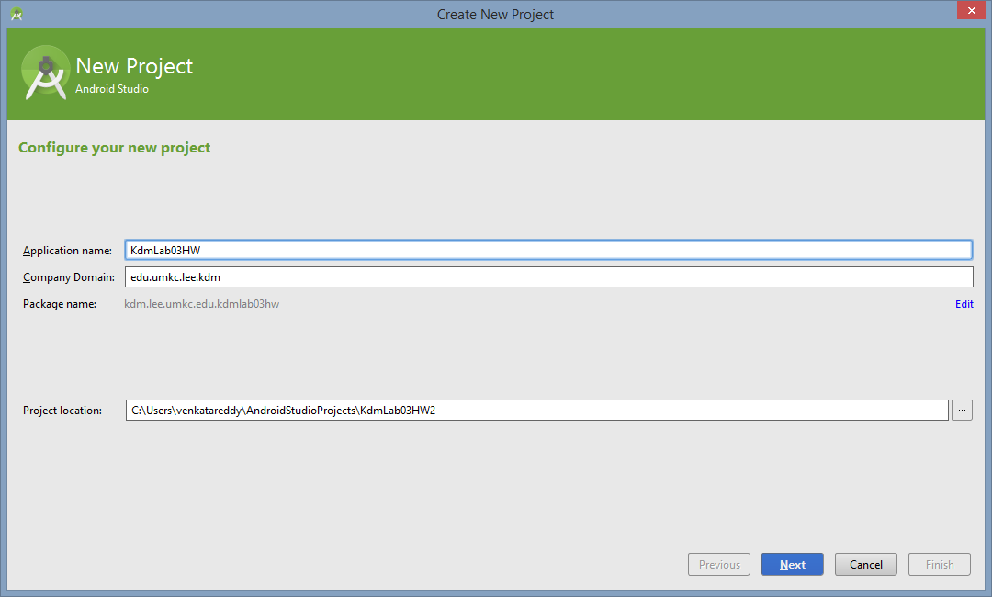

1. Drag a button and webView from widgets in Design

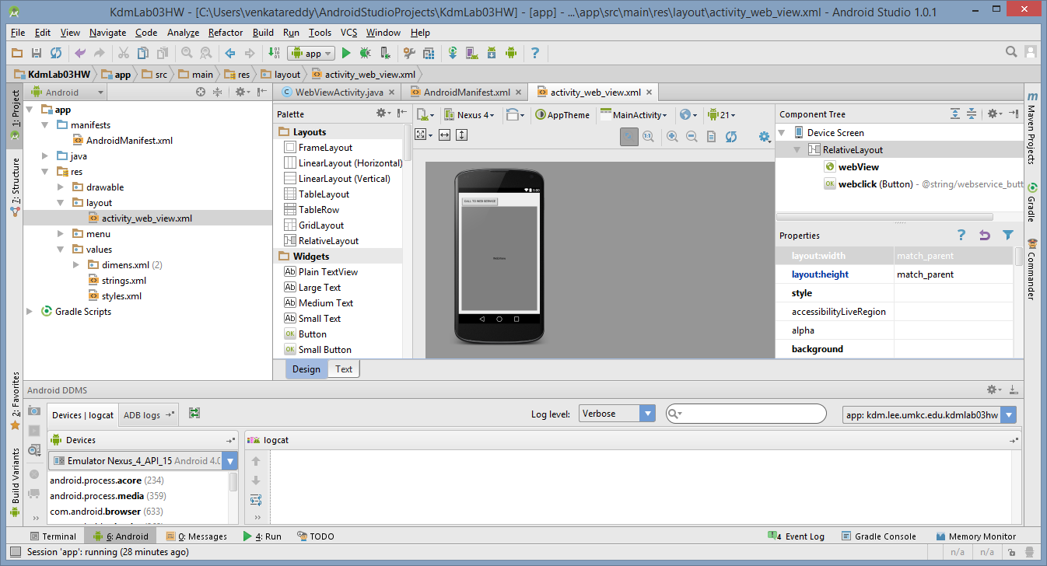

1. Change the text for button in layout file of text tab

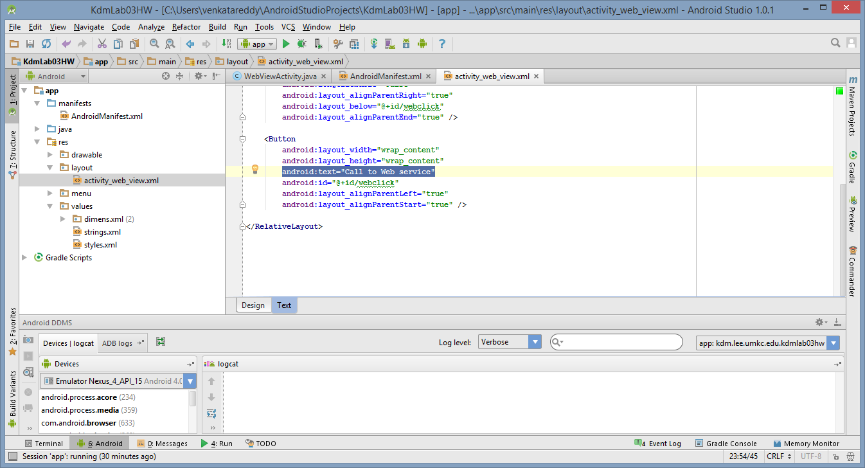

1. We have created two applications due to webview compatibility issues. As per android, developer should handle webview component depending upon API version. We have created one application with API level below 21 and one with 21 or above to make the difference.

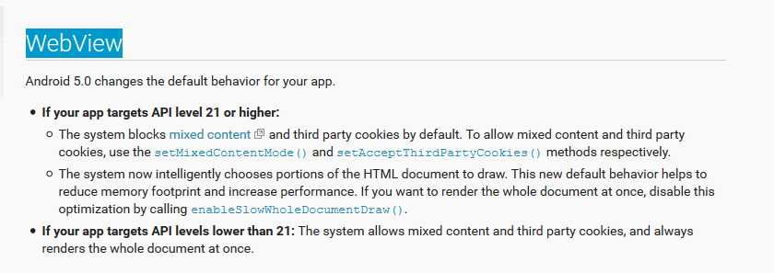

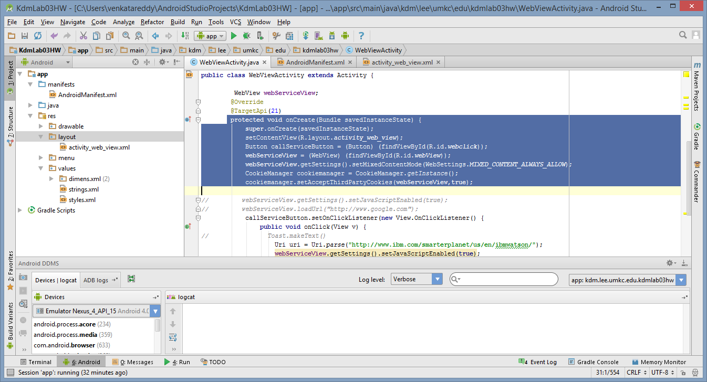

callServiceButton.setOnClickListener(new View.OnClickListener() {

public void onClick(View v) {

// Toast.makeText()

Uri uri = Uri.parse("http://www.ibm.com/smarterplanet/us/en/ibmwatson/");

webServiceView.getSettings().setJavaScriptEnabled(true);

webServiceView.loadUrl(String.valueOf(uri));

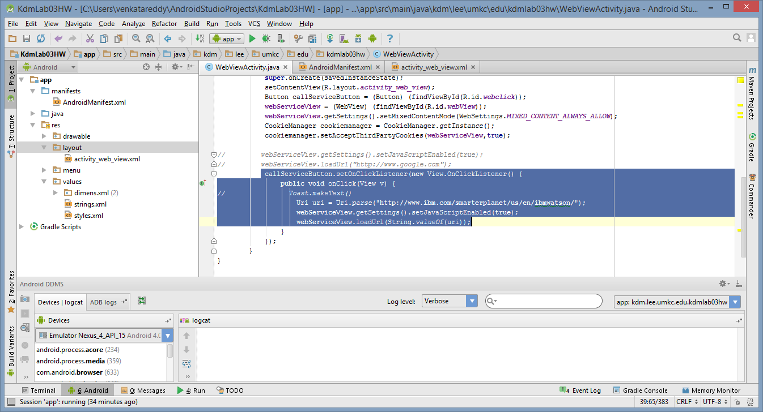

1. Downloaded the emulator for API version 15 and run the project.
2. The 1st project we created “MyAndroid0202” will run for all apps targeting API level below 21. Below is the corresponding screen shot which we ran for API level 15.
3. 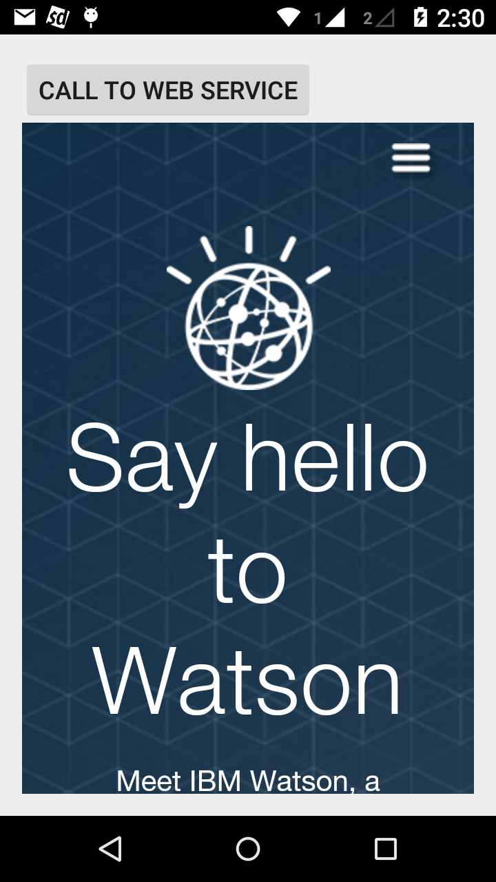
4. The second Project “KdmLab03HW” will work for all app targets for API level 21 or higher.
5. Below is the screen shot that shows incompatibility since the target emulator is API level 15.

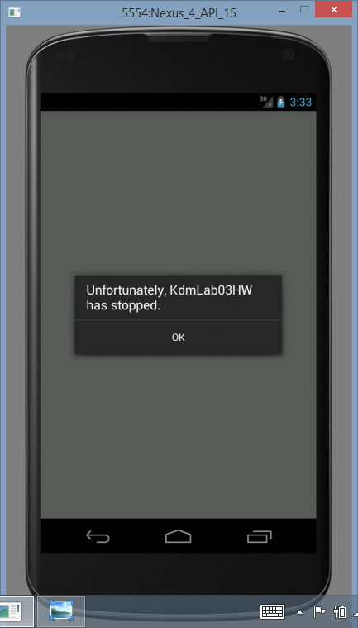

Below is the screen shot taken from mobile device with API level 21.

